# **Group Project: Phase 1**

**Introduction**

Some of us might be extremely well maintained with their monthly expenditure and calculates and keeps records of every dime they spend, others not so much. For both organized and unorganized kind of people, we introduce Personal Finance Management. It is a personal financial recording system that records, calculates and provides a visualisation of your expenditure. It makes life easier and convenient. You can just put in your daily spending, and it will calculate your monthly expenditure, savings and your income vs your actual expenses chart.

**1.0 Index**

The index page lets the User Login or Sign up to the website. It shows the user information about the website and any messages and news the user should know from the website.

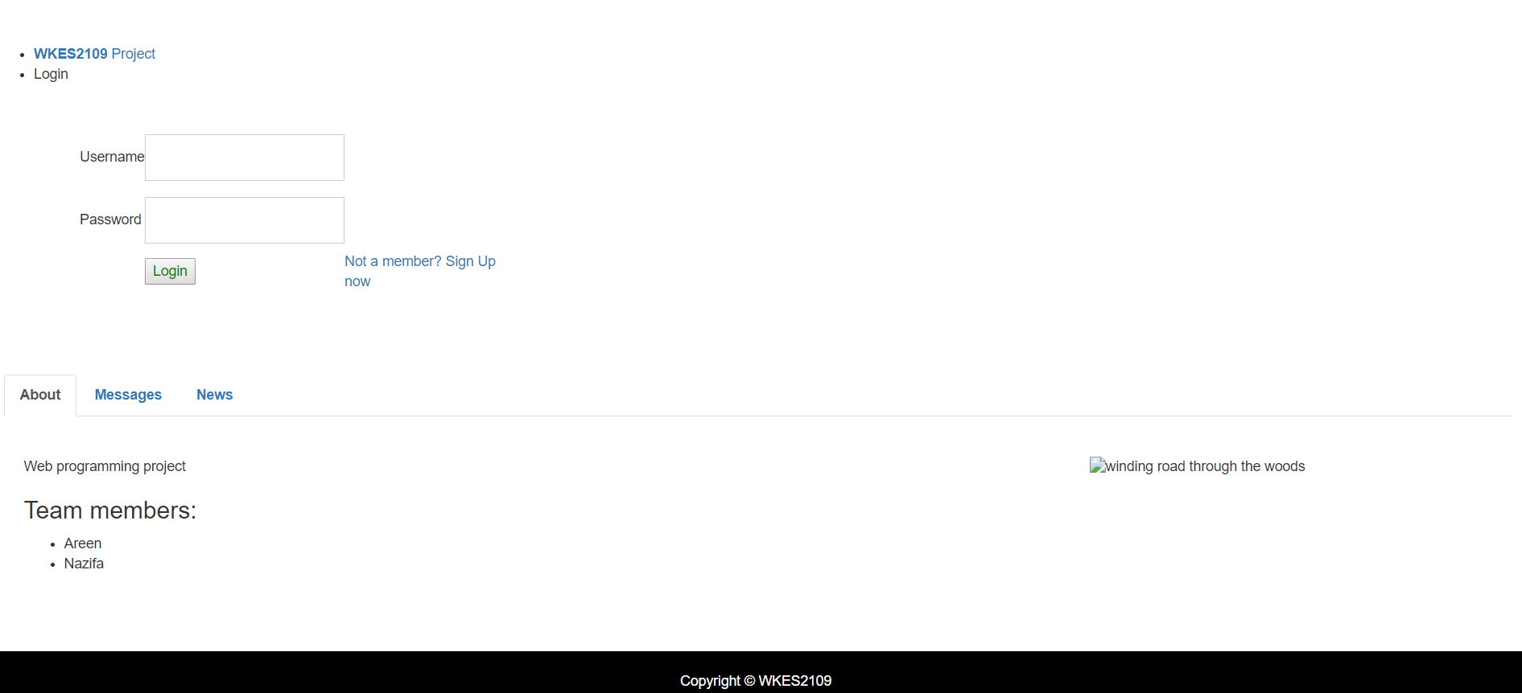

**Fig 1.1**

**1.1 Message**

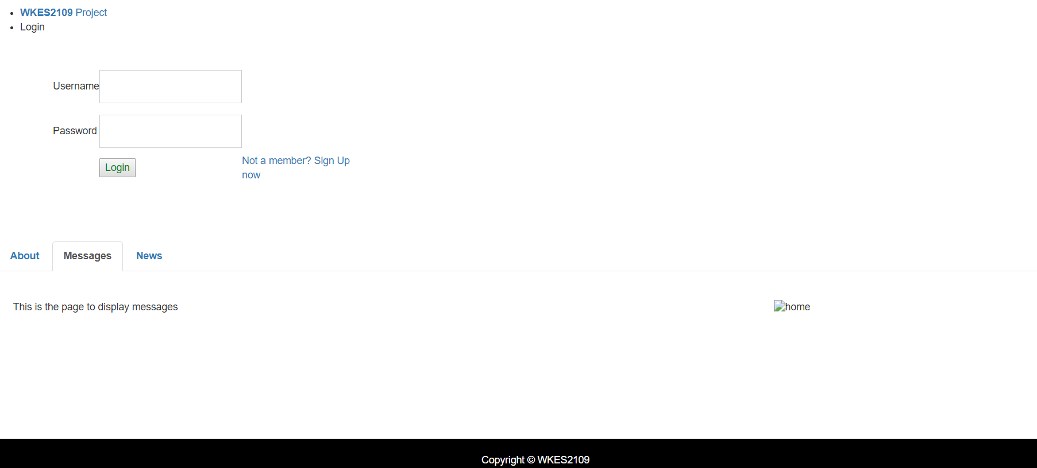

**Fig 1.2**

**1.2 News**

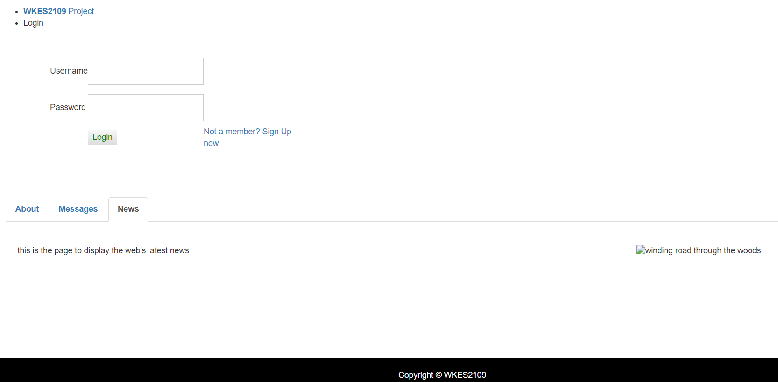

**Fig 1.3**

**Sign Up**

User has Sign Up to use the Financial Management web application. The user has to provide their First Name, Last Name, Email, Phone Number, NRIC Number, Username, Password and upload their Profile Picture. The fields are mandatory and will give an error message if not filled before clicking Sign Up.

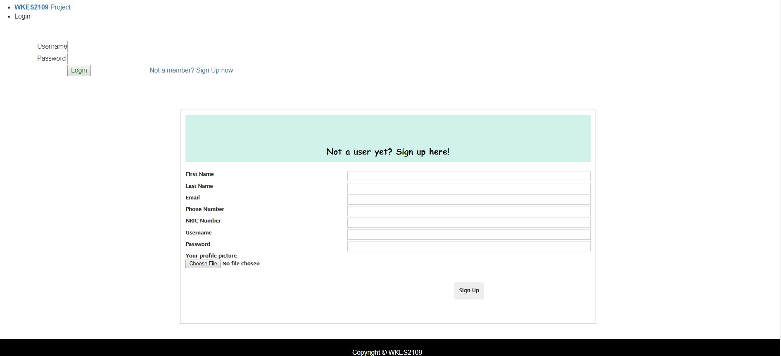

**Fig 2.1**

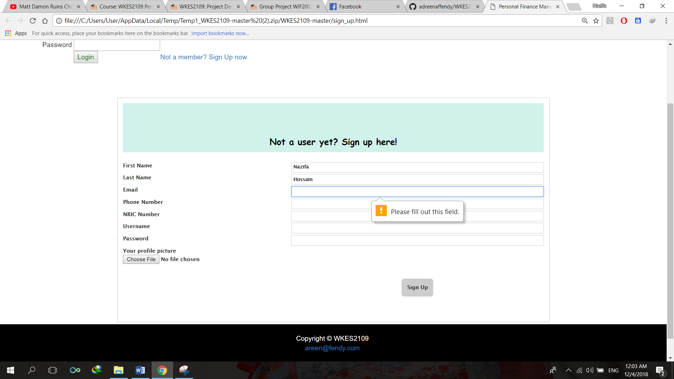

**Fig 2.2**

**3.0 Home Page**

The home page shows will show information about the website and give a general idea about the functionalities. Once you Sign up or Sign in, it lets you view your Goals, calculate and view your Daily Expenses, shows the Summary of your monthly expenses and your income vs you actual expense. You can also view the special features of this website by clicking the Features tab.

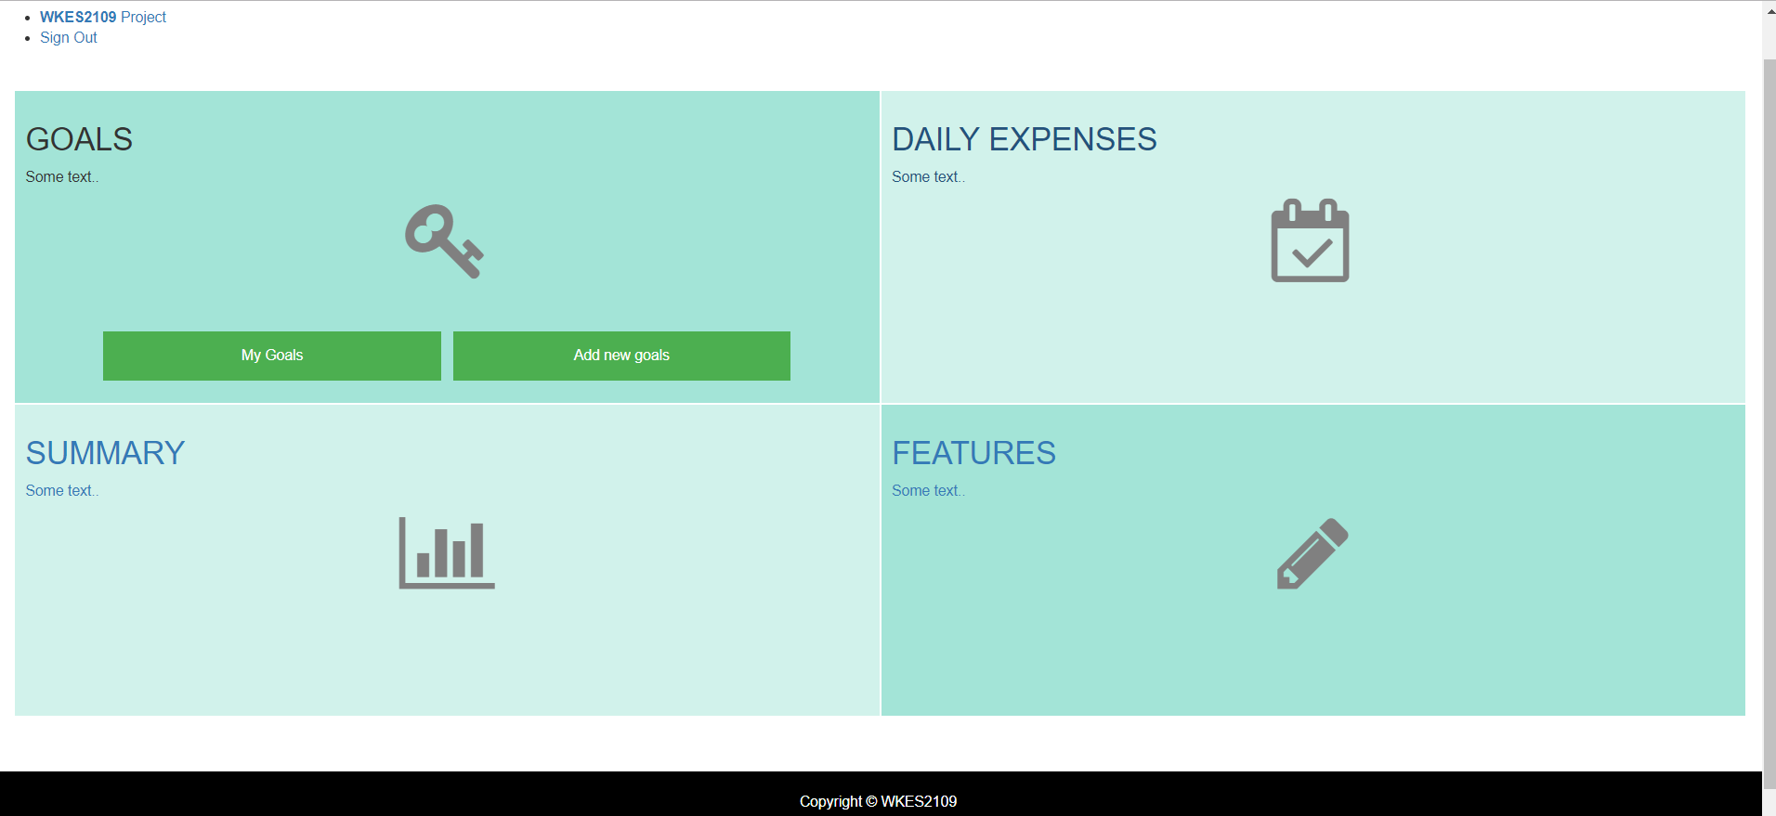

**Fig. 3**

**3.1 Add New Goals**

The Add New Goals feature on the Goals tile lets the user add new Goals for future. The user can set a name, the amount needed for the plan and amount needed to be saved monthly for it.

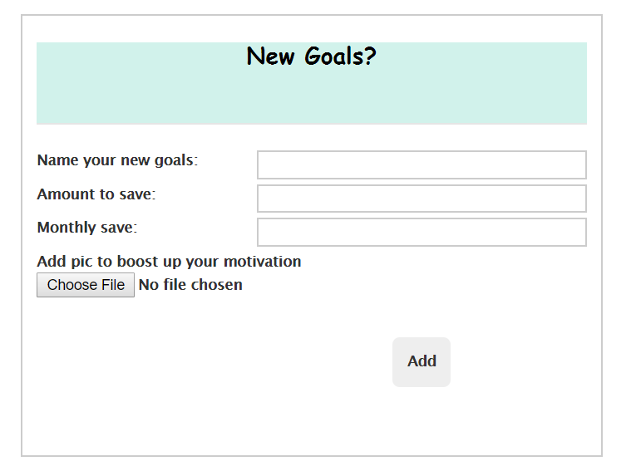

**4.0 Goals**

The Goals page will show the user their goal plans and saving plans. Here you can set up your goals, set a budget for it and save accordingly. You can also keep track of your savings for your each goal plan.

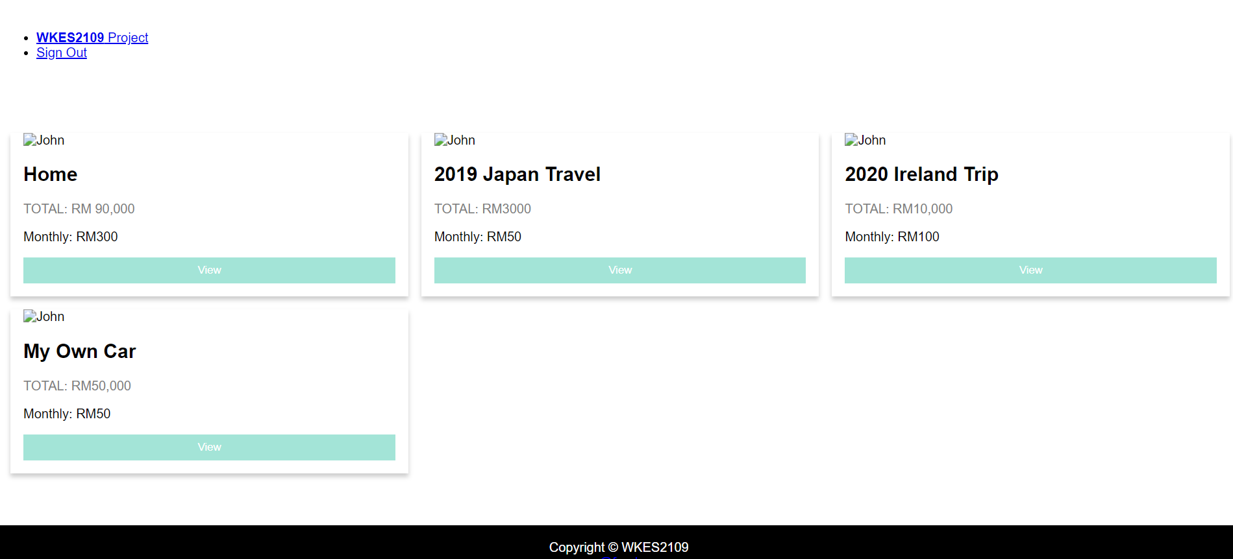

**Fig 4**

**5.0 Daily Expenses**

Users can view their daily expenses, including what percentage is spent on each category. They can also view how much they have spent on each category of expenditure in one particular month.

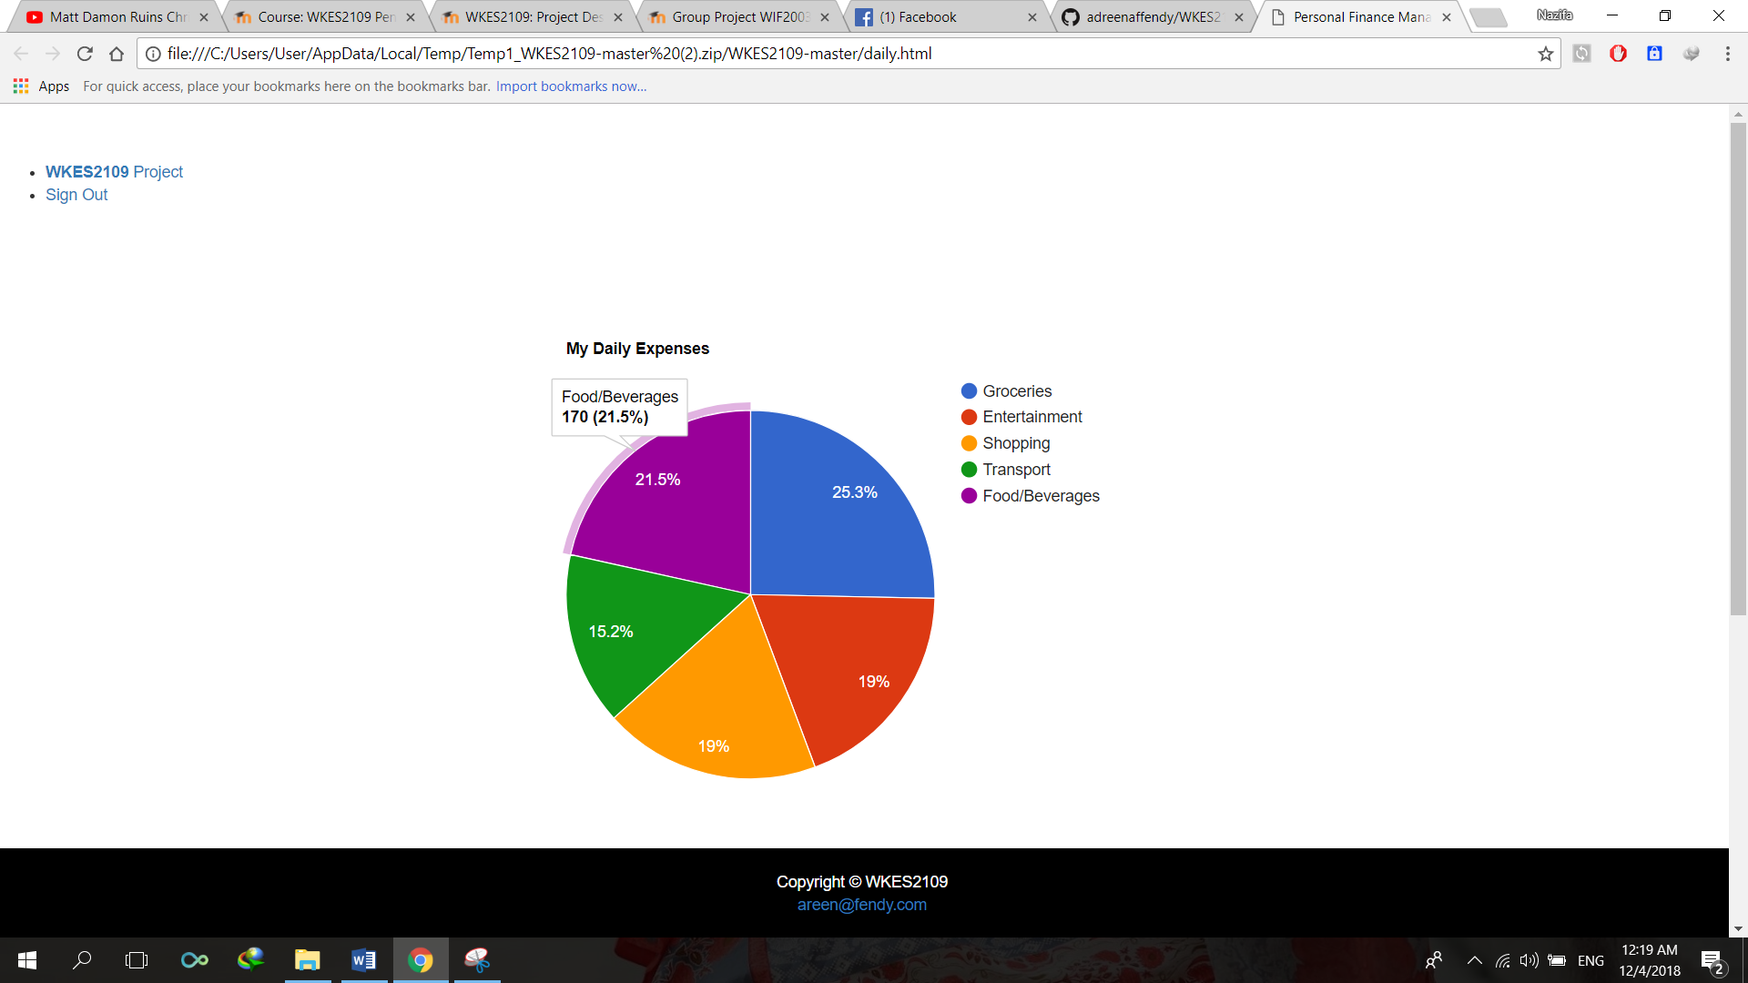

**Fig 5.1**

Scrolling down, users can also see their expenses per day basis. They can also add the a new date, category and amount spent on that category on the particular date. They also have the option to edit or delete their expenses. As you can see, this a quite convenient way to keep tab of your daily finances.

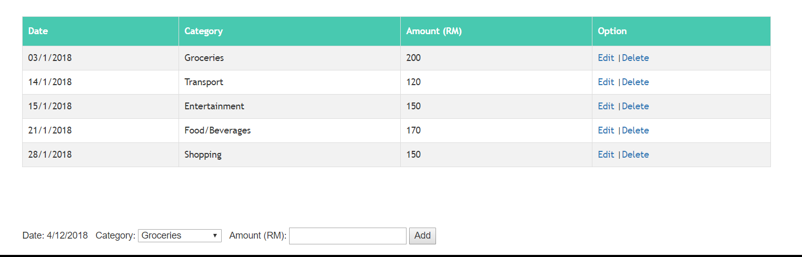

**Fig 5.2**

**6.0 Monthly Expenses**

Monthly expenses will provide the users with chart and details of their expenses on monthly basis. They can view how much they are spending against their income, and also show their percentage of monthly expenses on each category of expenditure.

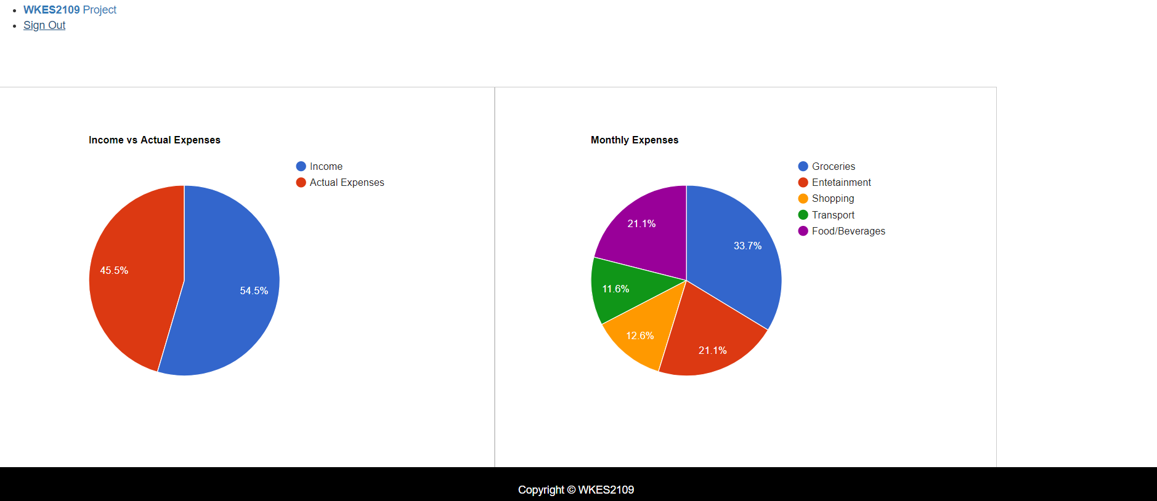

**Fig 6.1**

Users can also see their Total Income and Total expeses when they hover the mouse over the Pie chart.

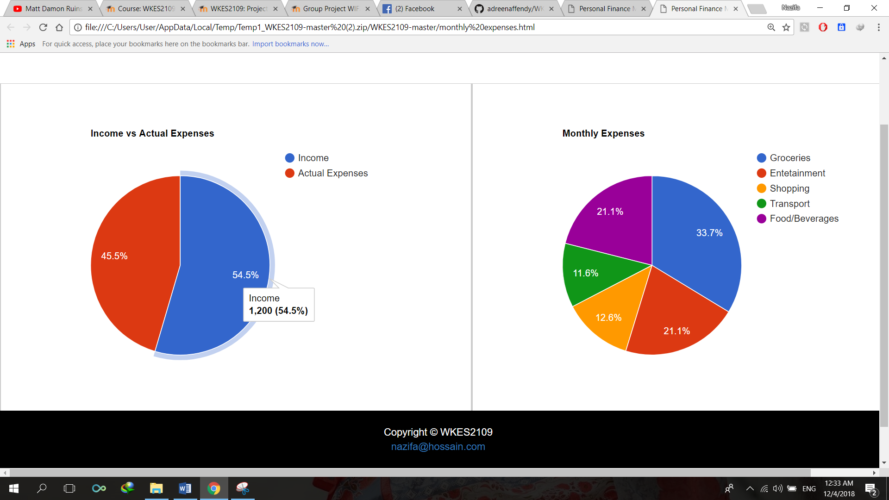

**Fig 6.2**

**7. 0 Special Features**

As Special Feature, the Personal Finance Management lets the user import important data and spreadsheet easily, without having to login. User can just put in the date beside the category they want the data for and type in a password, and then click Import to get the data as spreadsheet.

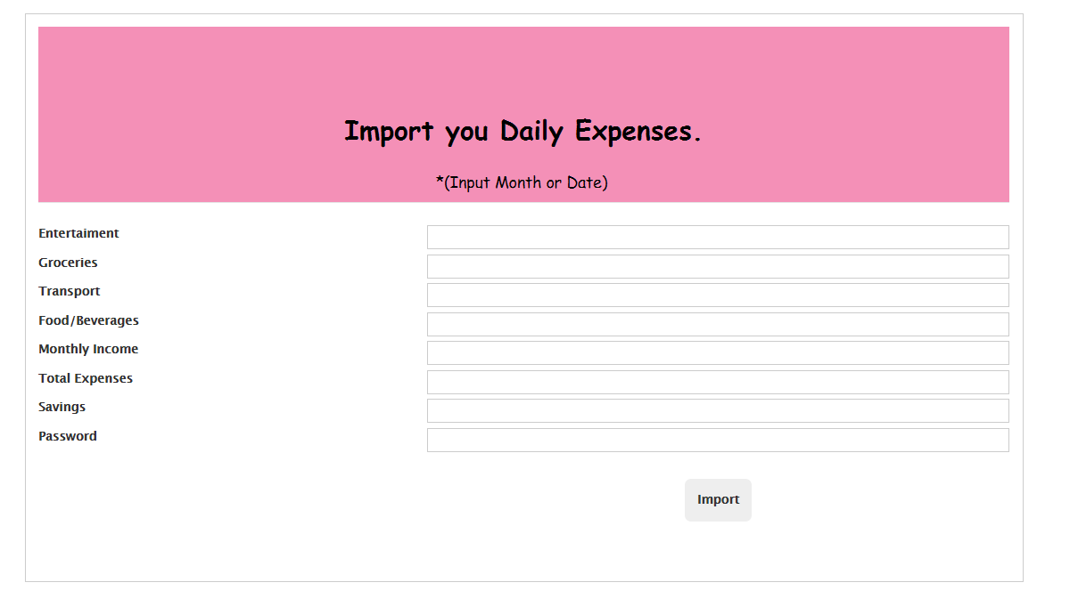

8.0 Tools and technologies

* GitHub
* HTML5
* CSS
* JavaScript
* Bootstrap